Preface

Introduction

Glossary

User requirements definition

System architecture

System requirements specification

System models

System evolution

Appendices

Index

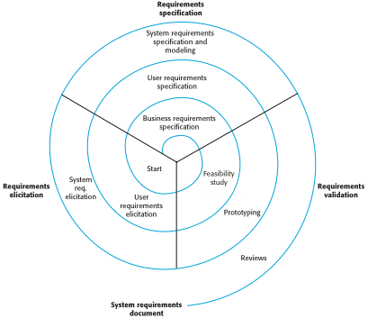

***Requirements Engineering Process***

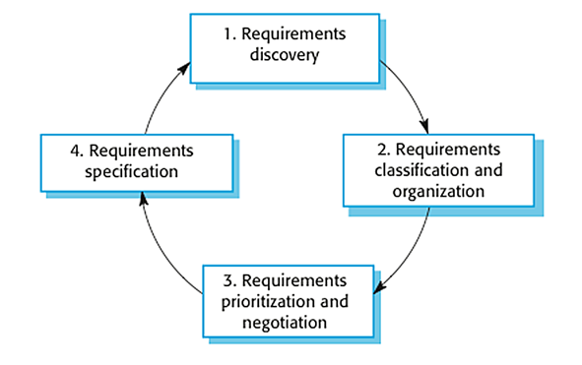

***Figure: Elicitation and Analysis***